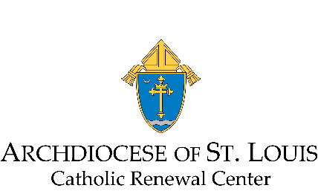
Application for Certificate in Spiritual Direction for the Archdiocese of St. Louis

Name
Address
Parish Attending
Phone Number
E-mail

Educational History
School
Degree Earned

Spiritual History

Spiritual History Continued

Ministry Experience

References Required
Name, phone number and email address for three references:
- Your current spiritual director
- Pastor of Parish you attend
- Person of choice

Your references will be asked the following questions:
- How long have you known the candidate?
- Do you believe the candidate is well suited and called to a ministry of spiritual direction?
- What do you believe are the candidate’s gifts for that ministry?

Short Essay Responses
Please respond thoughtfully and completely to each of the following prompts:

- Tell us a bit about your inner life, spiritual practices, and the relationships that sustain you.

- Identify one event from the past ten years in which you encountered God deeply. Describe how this experience has affected your sense of yourself, others, and the movements of God within you and within your life. How did this influence your sense of direction of God’s calling on your life?

- Describe your experience of receiving spiritual direction. What in this experience supports your desire to learn more about spiritual direction?

- Describe your current understanding of spiritual direction. What readings and personal experience have influenced your understanding?

- How or why do you feel called to the ministry of spiritual direction, and what has led you to this sense of call? What communal support are you receiving to undertake this training?

* upon reception of your application, an in-person interview will occur before final acceptance into the program is determined *

Applications are due by November 1, 2023.
Please send completed application to:
Jane Guenther
20 Archbishop May Dr.
St. Louis, MO 63119
janeguenther@archstl.org 314-792-7734

